HW2:

Contact Info Application

Martin Mudenda Bbela
2582912

Intro

This application will be able to switch between to activities. On opening it the user should be prompted to add contact information. Will switch to the 2nd activity to add their details. At this point the user can confirm the information which will bring them back to the first activity. This time the activity should have all the information selected in the previous page.

Method:

Main Activity

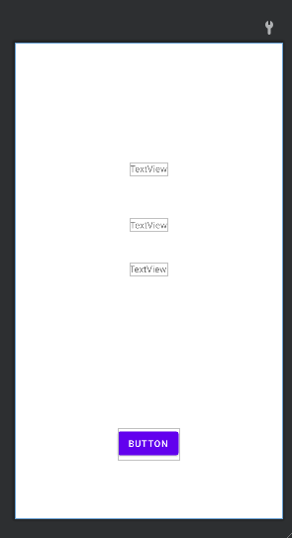
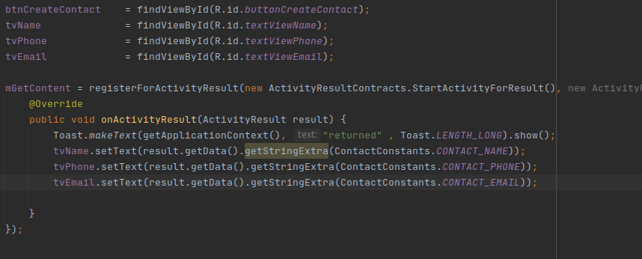
The main activity will have a layout containging three text boxes. They will be Empty initially. These will be wired to update on returning from the 2nd screen with information housed in an intent object. Note that for elegance, a Constants class is created that will only house strings that can be used to get and set extras in the Intent. The button is wired to start the next activity.

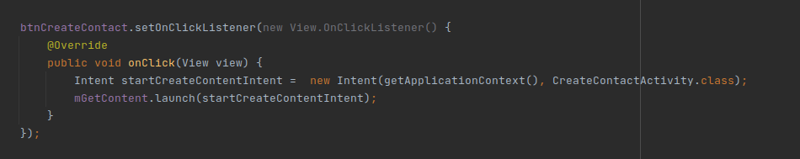
Activity 2
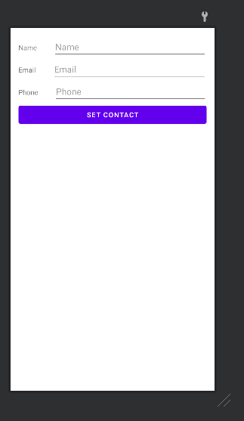
Activity will have 3 Edit Text Boxes corresponding to the contact information they user will have to put in. It also contains a button that will close this activity and return to the first activity with the text as written in the boxes.

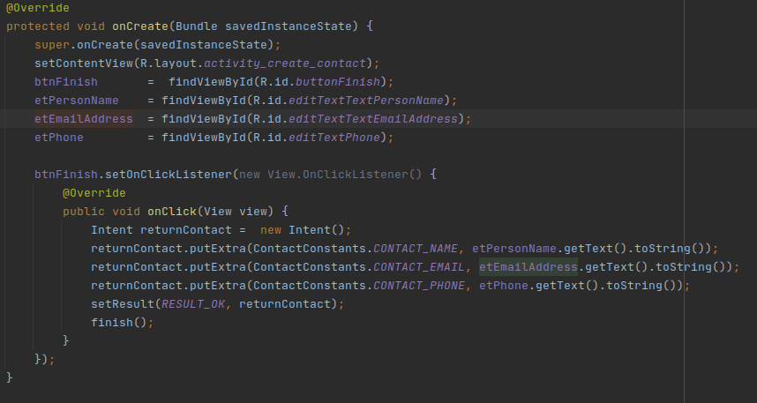

Result:

The application is able to prompt the user to fill in the Edit text boxes and return the user to the main activity with the Contact information
